Isaac Olson

Tumor Data Visualization

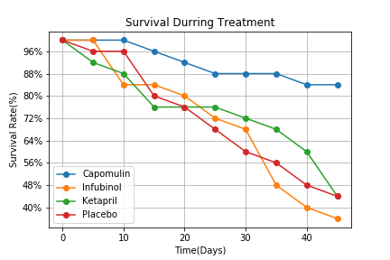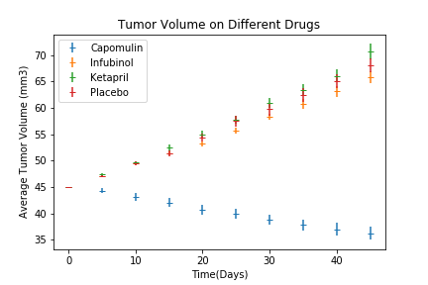In this graph we can it seems as if the only drug, of the three tested here, that had any effect on the size of the cancer was the Capomulin. Capomulin also has the only shrinking of the size of the tumors. These graphs seem to show that the survival on this drug was the best of the three, and the number of metastatic sites was lower than the other drugs. The other two drugs, Infubinol and Ketapril seemed to be no better in treating the cancer than the placebo, which is not what we would want with our drugs. In the data there was another drug, not included here for some unknown reasons, that also seemed like it could have promise, and may need more testing as well, Ramicane, but it may be outside the scope of these visualizations. With this data I would suggest continued research on Capomulin.

